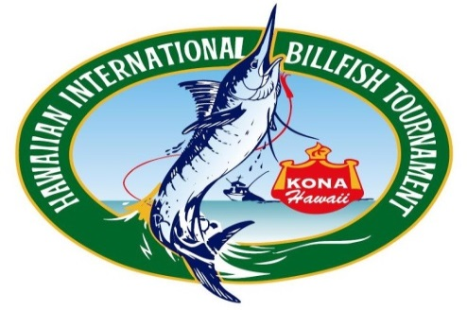

THE DIRECTORS OF THE HAWAIIAN INTERNATIONAL BILLFISH TOURNAMENT

HAVE THE PLEASURE TO EXTEND THIS INVITATION TO YOU AND YOUR TEAM

TO PARTICIPATE IN OUR ANNUAL TOURNAMENT IN

KAILUA-KONA, HAWAII, USA

“HIBT 62nd Anniversary”
July 27th – August 4th, 2024
“2nd Annual 4Flag Tournament”
July 23rd– July 26th, 2024

RSVP BEFORE MARCH 1ST, 2024

EMAIL: admin@hibtfishing.com MAIL: P.O. BOX 29638
FAX: 808-833-7756 HONOLULU, HI 96820

FOR MORE INFORMATION: www.hibtfishing.com

EARLY REGISTRATION $500
SIGN UP NOW!
2ND ANNUAL 4 FLAG TOURNAMENT 62ND HIBT

TEAM REPRESENTATION:___________________________________________________

TEAM NAME: _________________________________________________________

CAPTAIN / ANGLER NAME: _________________________________ No. of Team Members __________

ADDRESS: ______________________________________________________

CITY: _________________ STATE: _________ ZIP:_______ COUNTRY: ____________

PHONE: _________________________ CELL: ________________________

FAX: _____________________ EMAIL: ______________________________

TO HOLD A POSITION, A $500.00 us DEPOSIT IS REQUIRED.
CANCELLATION: FULL REFUND BY MARCH 1, 2024

