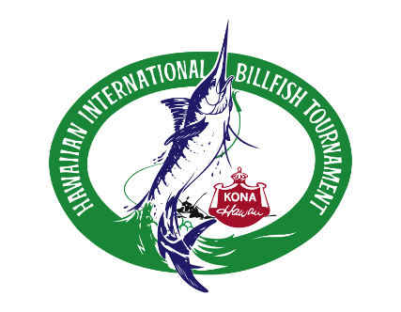
Hawaiian International
Billfish Tournament
61st Anniversary

2023 Miss Billfish Application
Name: ________________________________________________________________________________
Address: ______________________________________________________Apt.#: __________________
City: _______________________________ State: ____________________ Zip Code: _______________
Home Phone: _____________ Cell Phone: ______________ Email: ______________________________
Age: ______________ Height: ____________ Weight: _____________
(Must be at least 21 years old)
Personal Biography
(under 200 words)
Family, education, future plans, etc.: (use another page if you need more space)
___________________________________________________________________________
___________________________________________________________________________
___________________________________________________________________________
___________________________________________________________________________
___________________________________________________________________________
Applicant must attach 2 current photos – one head shot and one full body with bathing suit and/or pareo. Deadline for entry is May 1st. 2022.

Mail application and photos to: HIBT
P.O. Box 29638
Honolulu, Hawaii 96820

Or email to: hibt@hawaii.rr.com
Questions: call (808) 265-9641

Personal Bio continued:
_______________________________________________________________________________________
_______________________________________________________________________________________
_______________________________________________________________________________________
_______________________________________________________________________________________
_______________________________________________________________________________________
_______________________________________________________________________________________
_______________________________________________________________________________________
_______________________________________________________________________________________
2023 Miss Billfish Schedule
August 5th – 13th, 2023
Times are approximate.
Thursday, August 3rd 4p – 5p Orientation with the HIBT Directors
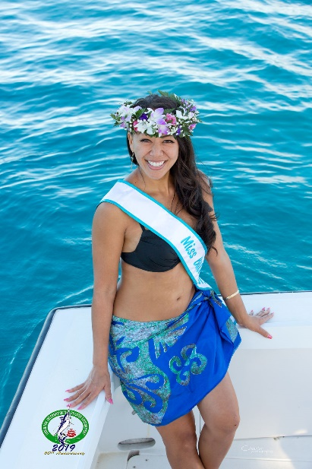
Friday, August 4th 5:30p – 8:30p Charter Boat Skipper”s Meeting – Kalua Pier
Miss Billfish 2019 Michelle Izawa
Saturday, August 5th TBA
Saturday, August 5th 5p – 8p Welcome Reception - Pier
Sunday, August 6th 8a – 1p Team Briefing – Courtyard Marriott
Sunday, August 6th 4:30p – 10p Opening Ceremonies & Meet The Teams – Hale Halawai
M-F August 7th – 11th 7a – 8a and 3p – 7p Photos with Anglers before and after fishing at the “Shouting Tent” – Kailua Pier
Friday, August 11th 5p – 10p Evening Event – Kailua Pier
Saturday, August 12th 10a – 4p TBA
4p -10p Awards Banquet
Sunday, August 13th 11a - 2p Volunteer’s Mahalo Luncheon

Miss Billfish is invited to attend all events and parties during the week and will be compensated for her time.
(all times are estimated)

Miss Billfish 2017 Kelina Wolf

